

**EC316 Summary (1):**

**Topics in Macroeconomics With Time Series Econometrics**

**Lewis Britton {201724452}**

EC316: Topics in Macroeconomics With Time Series Econometrics

Academic Year 2019/2020

Word Count: {N/A}

**EC316 Supplementary Notes**

**Lecture 1: Facts of Growth**

* Standard of living
* GDP $→$ happiness
* Rich country growth

**1: The Importance of Growth**

* Short-Run: fluctuations dominate
* Medium-Run: fluctuations dominate
* Long-Run: growth dominates

**2: Measuring Standard of Living**

* Growth $→$ standard of living
* Comparisons Over **Time**:
  + Variable: **GDP/Capita** (*output per capita*)
* Comparisons Over **Countries**:
  + Must use current exchange rate but too simplistic
    - Exch. varies more than living standard
    - Exch. doesn’t reflect non-traded prices like real estate, food etc.
    - {**ER GDP/Capita**}
  + Must use common pricing sets
    - Accounts for purchasing power (what can be bought)
    - Call this **Purchasing Power Parity** (PPP)
    - {**PPP-Converted GDP/Capita**}
  + **Example** (China vs. USA):

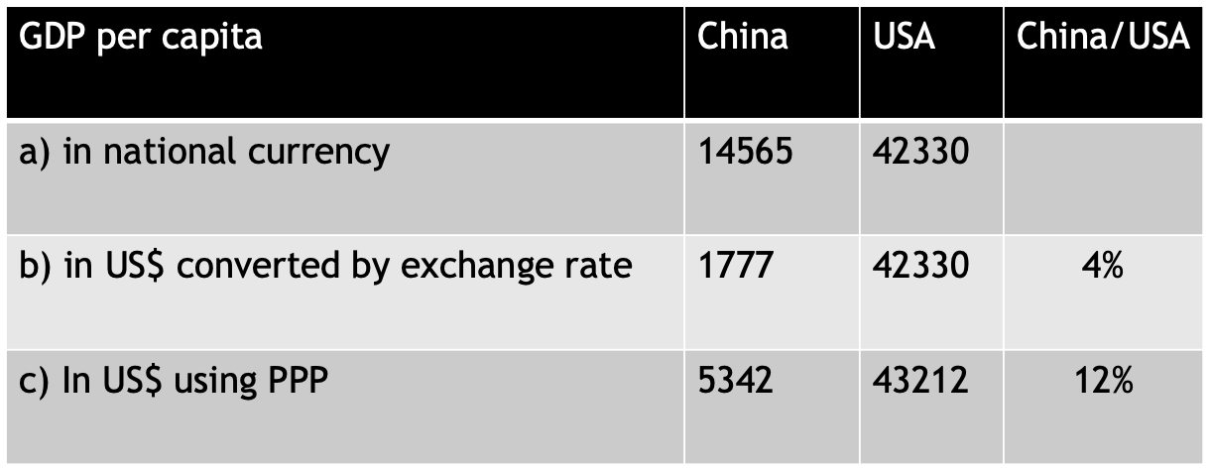

* + - PPP GDP/Capita > ER GDP/Capita (poorer countries) as non-traded products’ prices tend to be lower

**3: GDP & Happiness**

*More Y/Capita $→$ greater happiness?*

* Easterlin Paradox (it doesn’t):
  + **Over Time**: successive generations usually more affluent but no happier
  + **Across Countries**: higher happiness w/ higher income, only for poorer
  + **Across People/Country**: rich happier than poor
  + *Higher personal Y doesn’t increase happiness*
  + *Y relative to others maters more than absolute Y*
  + **Rich** **Countries**: policies aimed at increasing Y/Capita misdirected – doesn’t account for distribution
  + **Globalisation**: may make poor country people less happy if comparing themselves to rich countries
* Stevenson & Wolfers:
  + Simplify this: *“As income increases, so too does happiness. But doesn’t depend directly on it”*

**4: Economic Growth**

$g=\frac{{GDP}_{t+1}-{GDP}_{t}}{{GDP}_{t}}$

* *“An increase over t, in quantity of goods and services produced”*
* **Example**:
  + 1950 $→$ 2012 (1505.993bn $→$ 304.395bn)
$g={\left(\frac{{GDP}_{t2}}{{GDP}_{t1}}\right)}^{\frac{1}{(t2-t1)}}-1$

* Rate of Growth:
  + Real GDP: adjusts for inflation
  + GDP/Capita: adjusts for inflation and population size
  + PPP GDP/Capita: adjusts for inflation, population and relative prices

***4.1: Growth in Rich Countries***

* 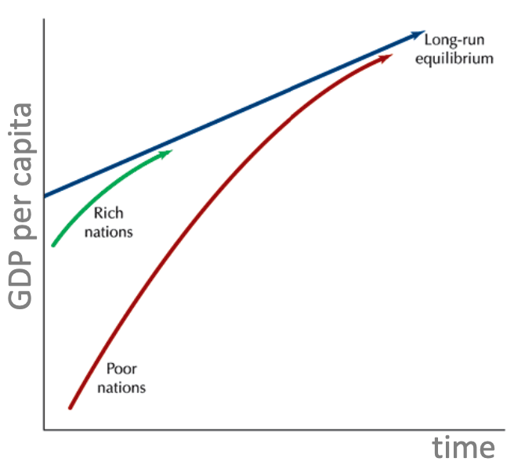Convergence in GDP/Capita:
  + L-R: Y coincides across time
  + Lower Y countries grow faster than  
    higher Y

***4.2: Broader Look at Growth Across Time***

* No clear relation between *g* since 1960 e.g. and GDP/Person in 1960 e.g.

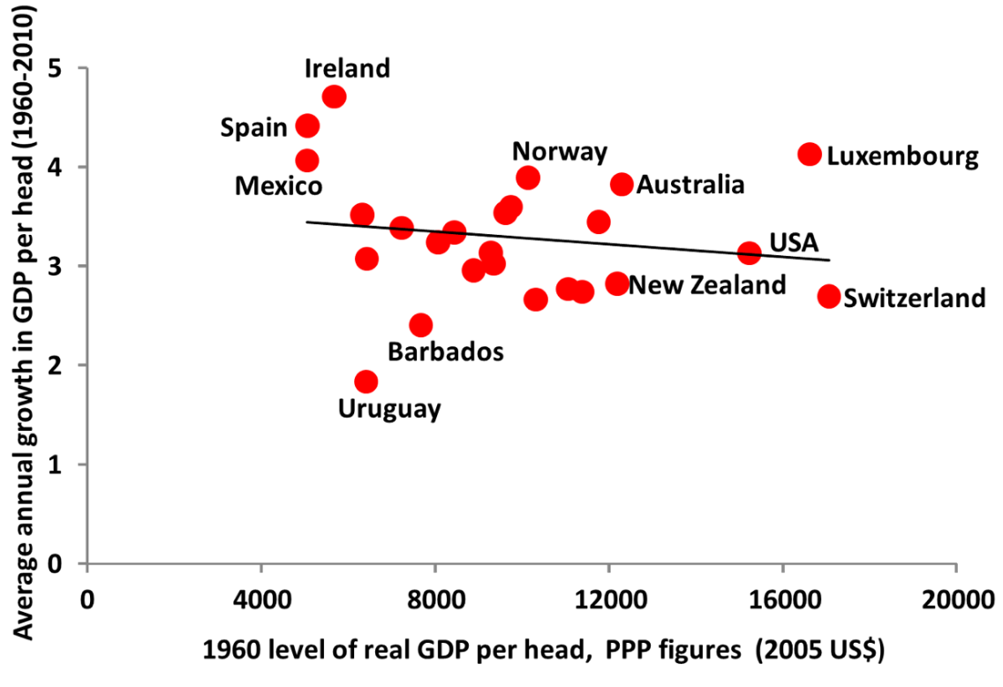

***4.3: Convergence Summary***

* Growth Across Countries
  + Almost all places w/ high GDP/Capita show clear **convergence**
  + **Convergence** visible in most Asian countries
  + **Convergence** not apparent in Africa

**5: Primer for Growth**

* Basic Solow model:
  1. Production function
  2. Capital accumulation equation

***5.1: Aggregate Production Function***

* + *Depends on state of Technology – what’s available influencing level of production*
* **Returns to Scale**:
 $λY=Y\left(λK,λN\right)$

 + *“If K and N doubled e.g. Y is doubled”*
  + What happens if only one factor is multiplied? (diminishing returns):
  + **Decreasing Return to Capital**: increases in K lead to **log** increasing Y
  + **Decreasing Return to Labour**: increases in N lead to **log** increasing Y
 $\frac{Y}{N}=\frac{Y}{N}\left(\frac{K}{N},\frac{N}{N}\right)=\frac{Y}{N}\left(\frac{K}{N},1\right)=Output/Worker$

 + *Increases in $\frac{Y}{N}$ come from increases in $\frac{K}{N}$ (capital accumulation)*
  + *Or from Technological progress*
* Hence:
  1. Capital Accumulation
  2. Technology

***5.2: Capital Accumulation Effect***

***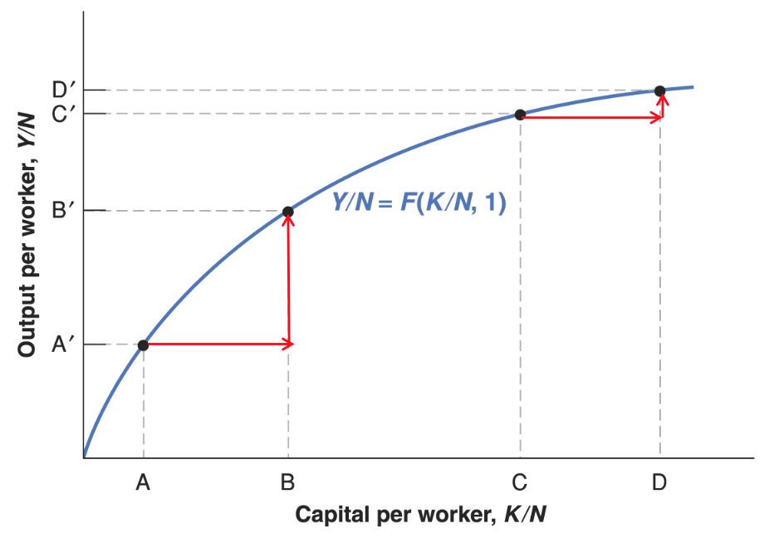*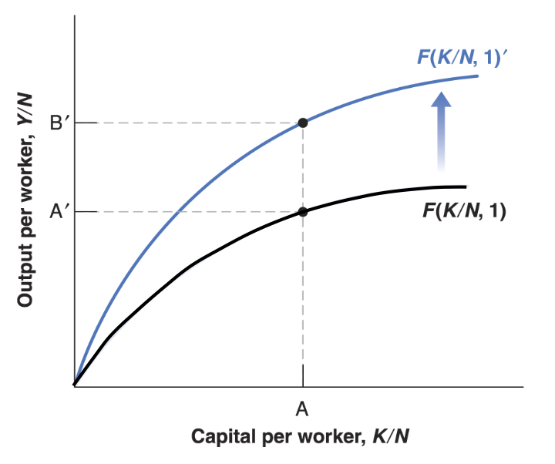**

$$→$$

* *Diminishing returns – log*
* But, improve Technology to pivot function

***5.3: Conclusions***

* Capital Accumulation: growth but not sustainable due to **returns to scale**
* Technology: growth and sustainable

**Lecture 2: Saving, Capital Accumulation & Output**

* Initial Solow Model
  + Savings
  + Capital Accumulation
  + Output
* Optimal Savings Rate: *Golden Rule*

**1: Building the Solow Model**

* Long-Run output
* Savings-:-GDP ratio
* **Increase** in savings: higher *g* for some time, higher living standard eventually
* 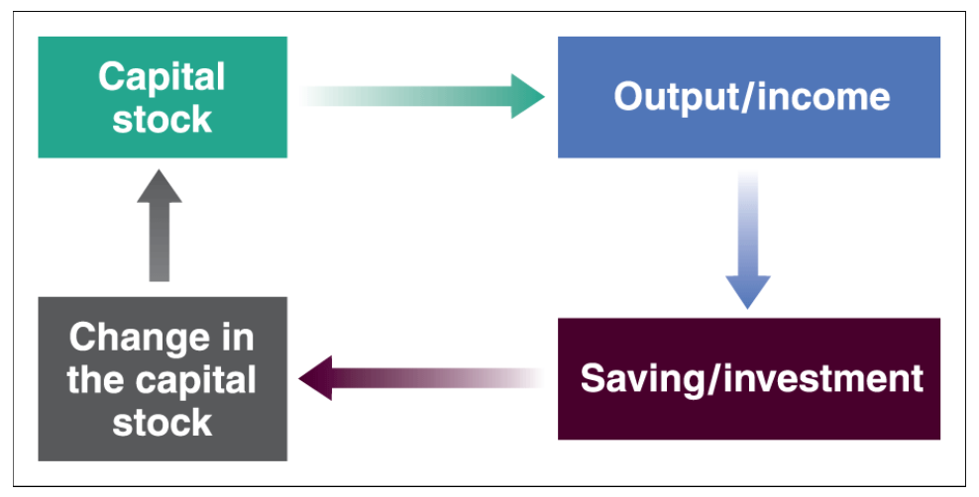(1) Capital determines output, (2) determines savings, (3) determines capital accumulated

**2: Capital Determines Output (1:3)**

* Recall: $Y=f\left(K,N\right)=Output$
* Intensive form: $\frac{Y}{N}=f\left(\frac{K}{N},1\right)$
  + Extend here to: $*\frac{Y_{t}}{N}=f\left(\frac{K_{t}}{N}\right)*$
* Assume:
  + Size of population and unemployment are constant
  + No technological progress

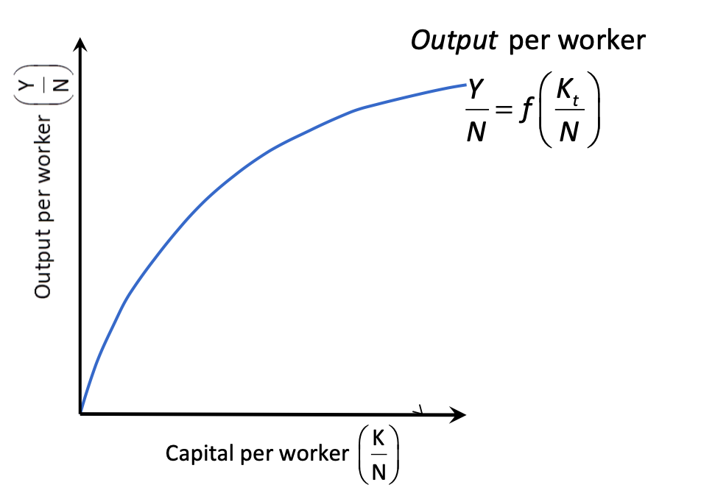

* Recall: log $→$ diminishing returns   
  w/ just Capital Accumulation

**3: Output Determines Savings/Investment (2:3)**

* Assume:
  + Closed economy {$Y=C+I+G$}
  + Private savings, so public savings are 0 {$\left(T-G\right)=0$}
  + Private savings proportionate to *Y* {$S=sY \{0<s<1\}$}
* Given these:
 $Y=C+I+G \left\{-T\right\}$

 $Y-T=C+I+G-T \left\{-C\right\}$

$Y-T-C=I+G-T \left\{Private Savings=S=\left(Y-T-C\right)\right\}$

$S=I+G+T$

$I=S-\left(T-G\right) \left\{\left(T-G=0\right)\right\}$

$I=S$

$I=sY$ + as req.
  + *“Investment also proportionate to output”*
* Investment as Function of Capital:
 $* \frac{I_{t}}{N}=s\frac{Y_{t}}{N}=sf\left(\frac{K_{t}}{N}\right)*$

 + **Investment Function** similar to **Production Function**

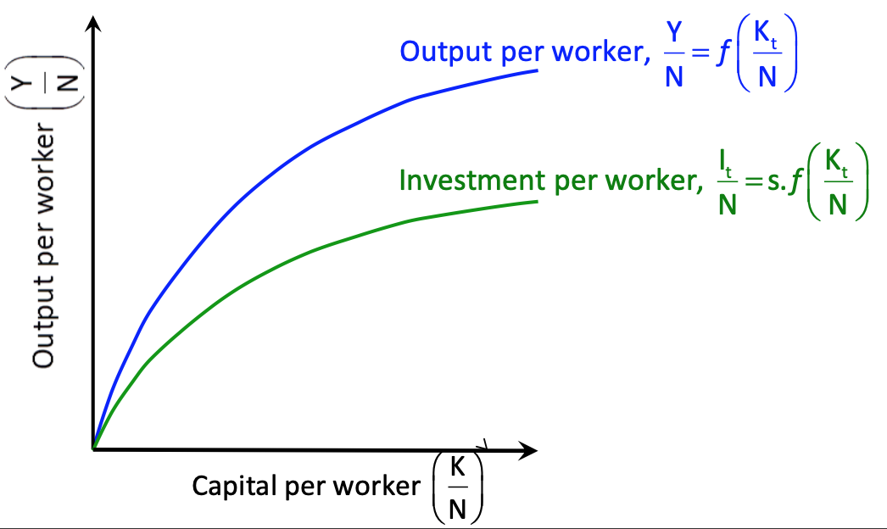

**4: Investment Determines Capital Accumulation (3:3)**

* $I_{t}$: purchase of new machinery etc.
* $K_{t}$: existence of machinery etc.
* **Capital Stock**:
$K_{t+1}={\left(1-δ\right)K}_{t}+I_{t} \left\{δ=Depreciation\right\}$

$K_{t+1}={\left(1-δ\right)K}_{t}+{sY}_{t}$

* **Capital Stock/Worker**:

 $\frac{K_{t+1}}{N}=\left(1-δ\right)\frac{K_{t}}{N}+s\frac{Y_{t}}{N} \{Expand Brackets\}$

 $\frac{K_{t+1}}{N}=\frac{K_{t}}{N}-δ\frac{K_{t}}{N}+s\frac{Y_{t}}{N} \left\{Subtract \frac{K_{t}}{N}\right\}$

$*\frac{K_{t+1}}{N}-\frac{K_{t}}{N}=s\frac{Y_{t}}{N}-δ\frac{K_{t}}{N}=∆K*\{s\frac{Y_{t}}{N}=sf\left(\frac{K_{t}}{N}\right)\}$

+ *“Change in Capital Stock = Investment – Depreciation”*

**5: Steady State of Capital/Worker**

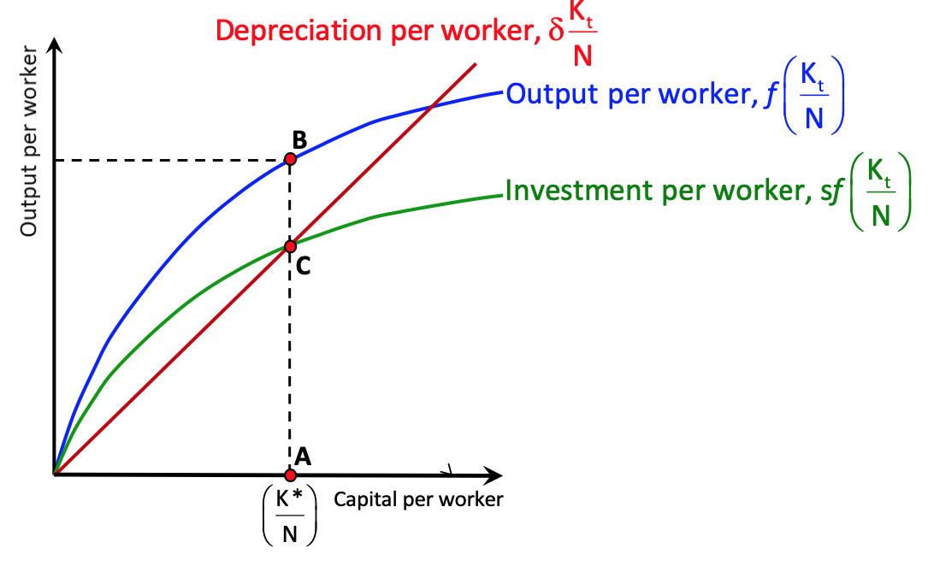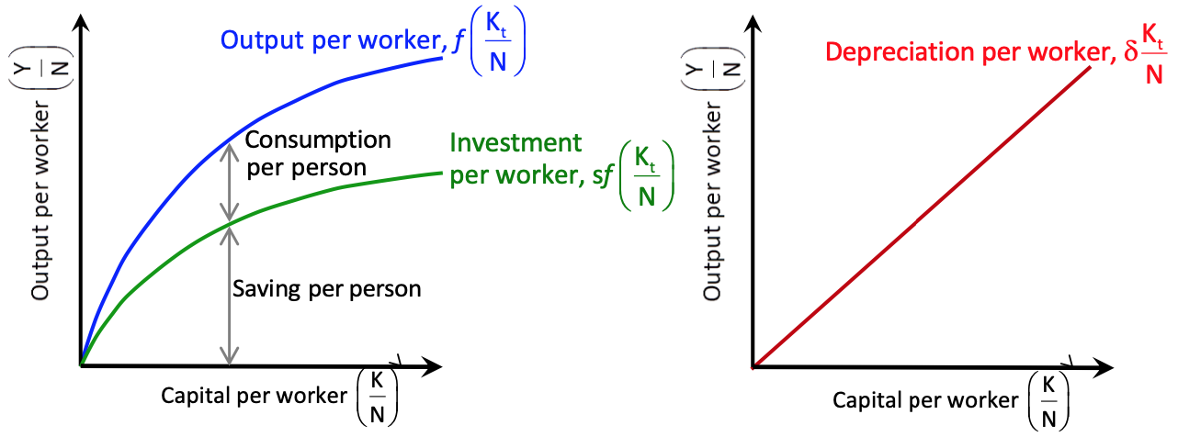

$→$

* Point C: $\frac{I}{N}$ offsets **depreciation**

***5.2: Return to Steady Rate***

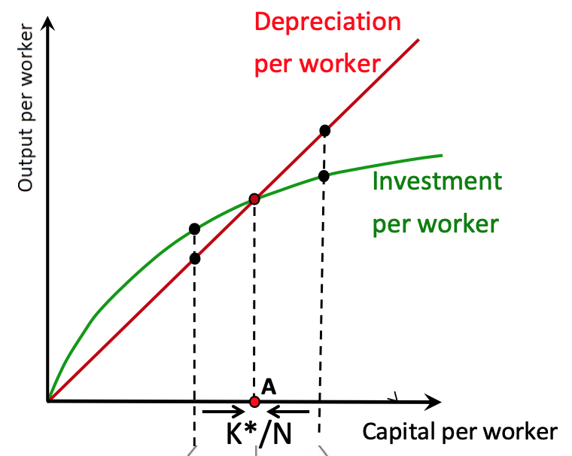

* **Left**: $\left\{sf\left(\frac{K_{t}}{N}\right)>δ\frac{K_{t}}{N}\right\}; \frac{K_{t}}{N} Rises$
  + *Savings exceed deprecation: replace capital*
* **Right**: $\left\{sf\left(\frac{K_{t}}{N}\right)<δ\frac{K_{t}}{N}\right\}; \frac{K_{t}}{N} Decreases$
  + *Depreciation exceeds savings: lose capital*
* ${\frac{K_{t}}{N}}^{*}$: $\left\{sf\left(\frac{K_{t}}{N}\right)=δ\frac{K_{t}}{N}\right\}$
  + *Steady rate of capital*
* 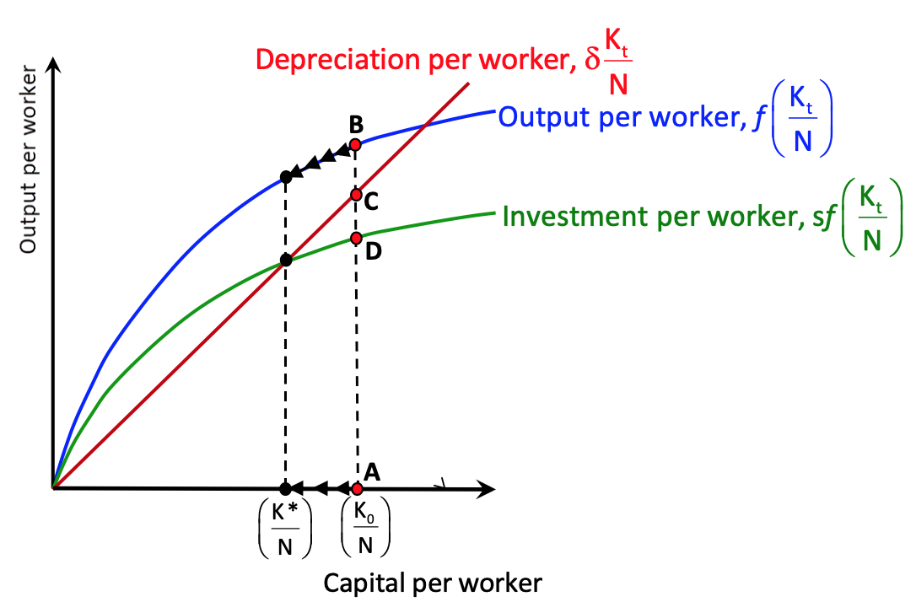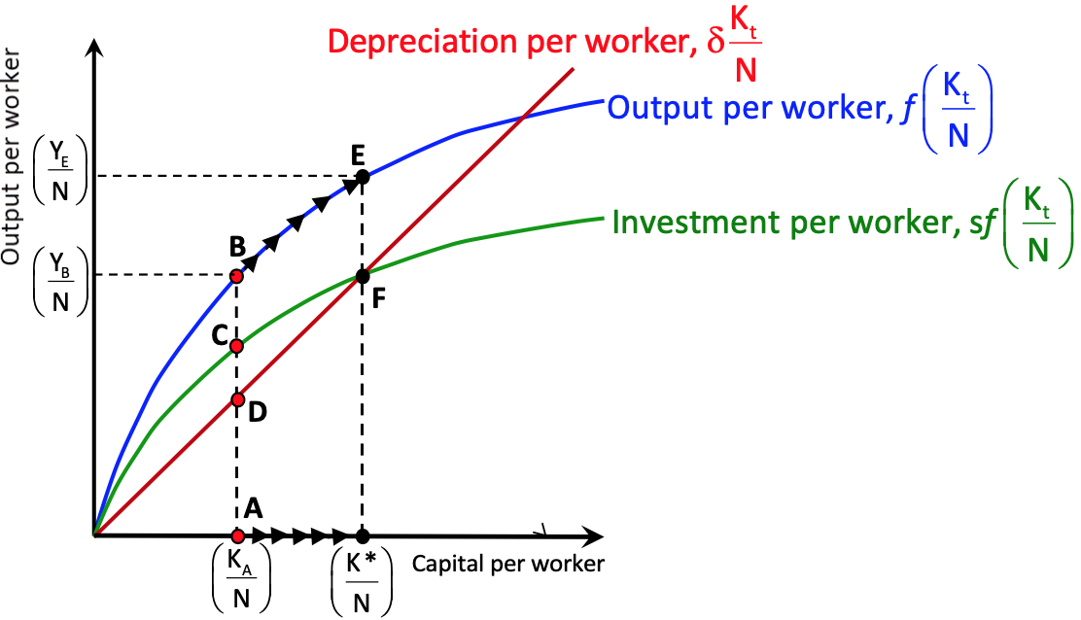Hence:

***5.3: Comparing Steady Rates Cross-Country***

*Holding technology constant – Solow explains standard of living by savings rates*

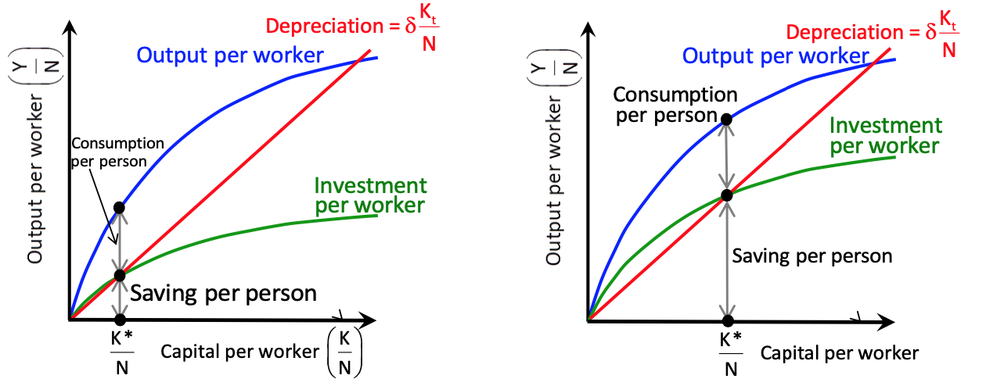

***5.4: Increase in Savings Rate***

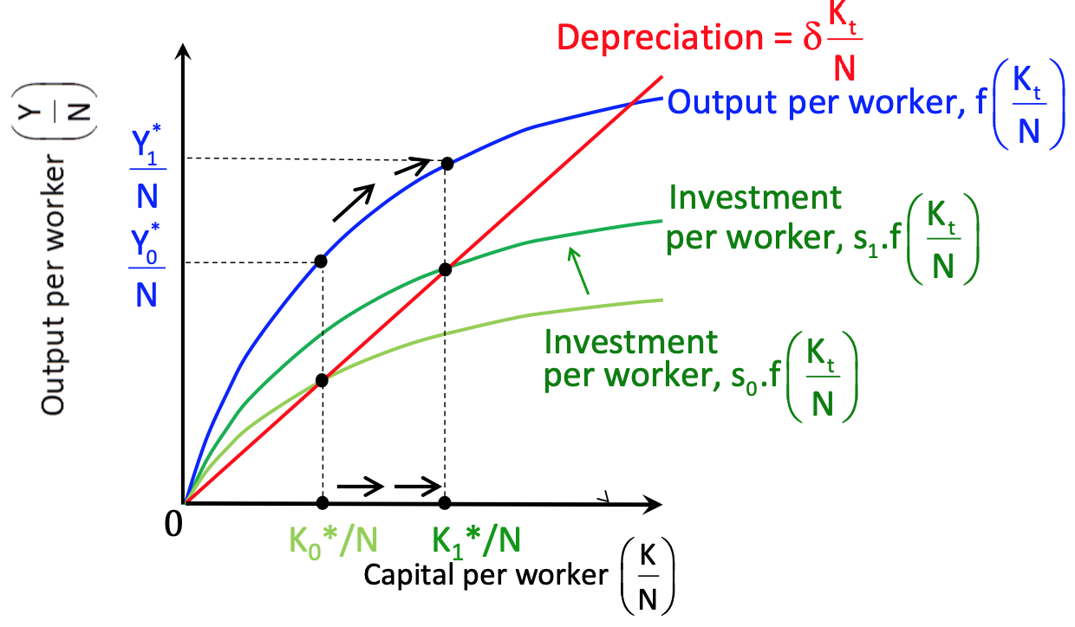

***5.5: Conclusions - Savings Rate on Growth/Capita***

1. Saving rate no effect on L-R *g* w/o Technology progress
2. Saving rate determines **Steady** **Rate** of output/capita
3. Saving rate $→$ better capital replacement $→$ higher output

*Wont last in L-R due to* ***Diminishing Returns*** *to capital and labour – need Technology*

**6: The Golden Rule**

***6.1: Golden Rule Level of Savings***

* Saving and Consumption
  + Expect increase in *s* to come from decrease in *C*
  + Does *s* increase *C* in L-R?
    - In steady rate, high *s* implies all goes towards improving depreciation – {*C* = 0}
* $\max\left\{\frac{K}{N}\right\}$ for $\max\left\{\frac{C}{N}\right\}$
* If *K* stock too high, *Y* used to maintain overly-large stock, *C* low
* If *K* stock too low, *Y* used to maintain *C*, *K* too low to support *Y*

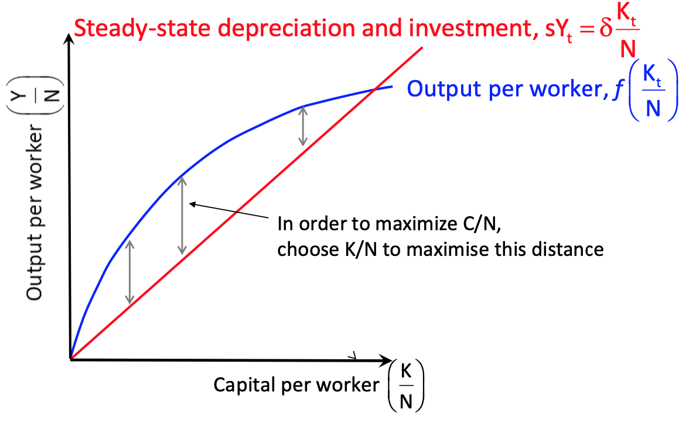

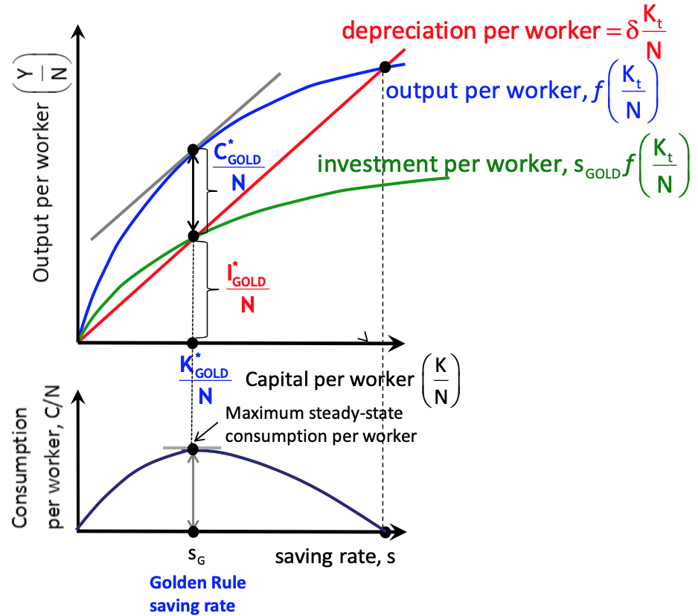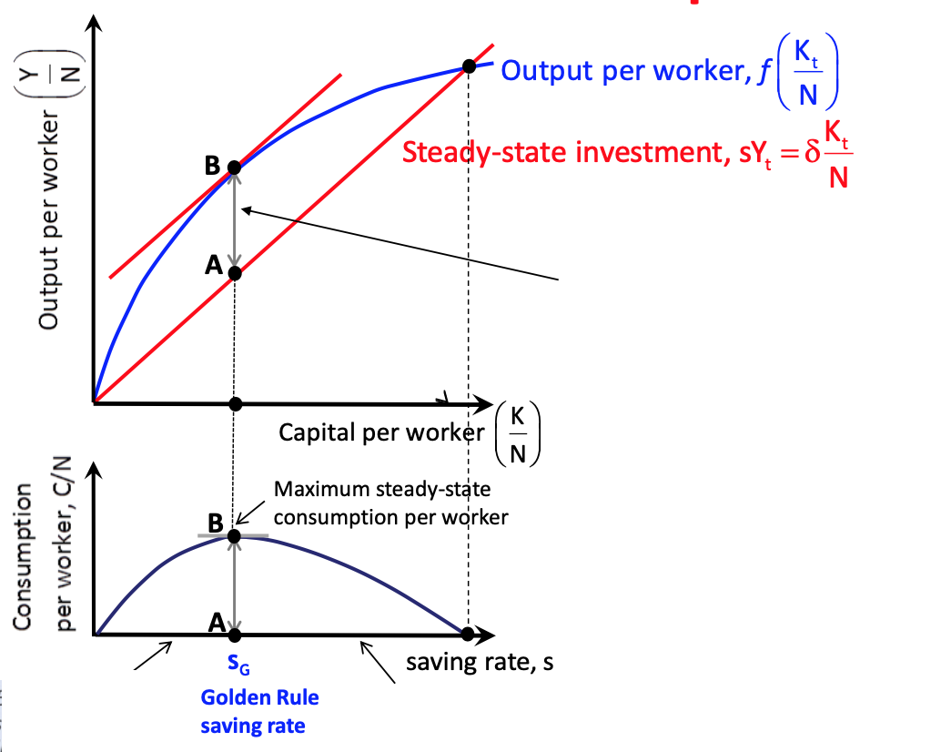

* Distance maximised at tangent B
* Set $\frac{K}{N}$ equal to slope of production function
  + i.e. **Marginal Product of Capital/Capita**
* Equal to slope of depreciation line
  + i.e. $\{MPK=δ\}$
* Increase in savings $→$ increase then decrease in **steady-rate $\frac{C}{N}$** :

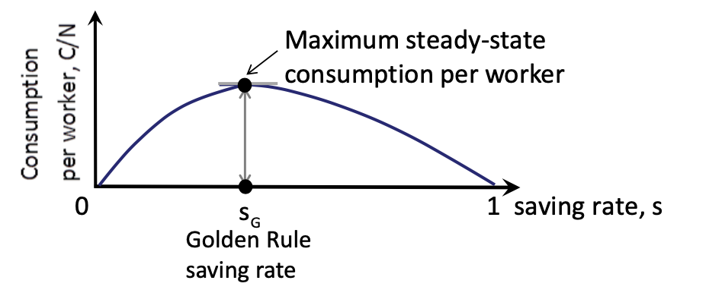

**7: Extending Model to Human Capital**

* Human Capital: set of skills held by workers
* Economy w/ highly skilled workers, more productive than ones which don’t
* Given Physical Capital and Labour, increase Human Capital $→$ increases output $→$ higher **steady-state** output and capital $→$ may explain cross-country *g*

***7.1: Extending Production***

* $\frac{Y_{t}}{N}=f\left(\frac{K_{t}}{N},\frac{H_{t}}{N} \right)$; all have **positive corr.**

**8: Conclusions**

* *“L-R: output/capita depends on savings (s) and education, basically human capital (H)”*

**Lecture 3: PWD Data for Cross-Country Comparison (Econometrics)**

* Simple Regression to test Convergence

**1: International Comparisons**

1. Start w/ Real GDP (constant prices over time etc.)
2. Adjust for PPP (allow for differences in rel. prices of goods/services)
3. Country size differences: look at GDP per Capita (PPP US$/Population)

**2: GDP/Capita Measuring Welfare (Indicators)**

* Quality of environment
* Leisure time
* Non-market activity (e.g. mother cares for child)
* Life expectancy
* Income distribution
* Crime, corruption and political instability

***2.1: Raising GDP/Capita – Problems***

* All must work more hours/week and retire later
* Encourages child labour
* Firms use cheaper production methods (pollution)
* Unnecessary trade surplus (produce too much for export, nothing in ret.)

***2.2: France vs. US Example (GDP vs. GDP/Capita)***

* GDP lower in France
* Indicators are better in France

***2.3: Having a Larger GDP/Capita (GDP Reflection)***

* Better schools
* Cleaner environment
* Better health care
* Better infrastructure
* *Indicators often Positively Correlated w/ GDP Reflection*

**3: Regression**

* Is GDP/Capita 1960 a good indicator of GDP/Capita 2010?

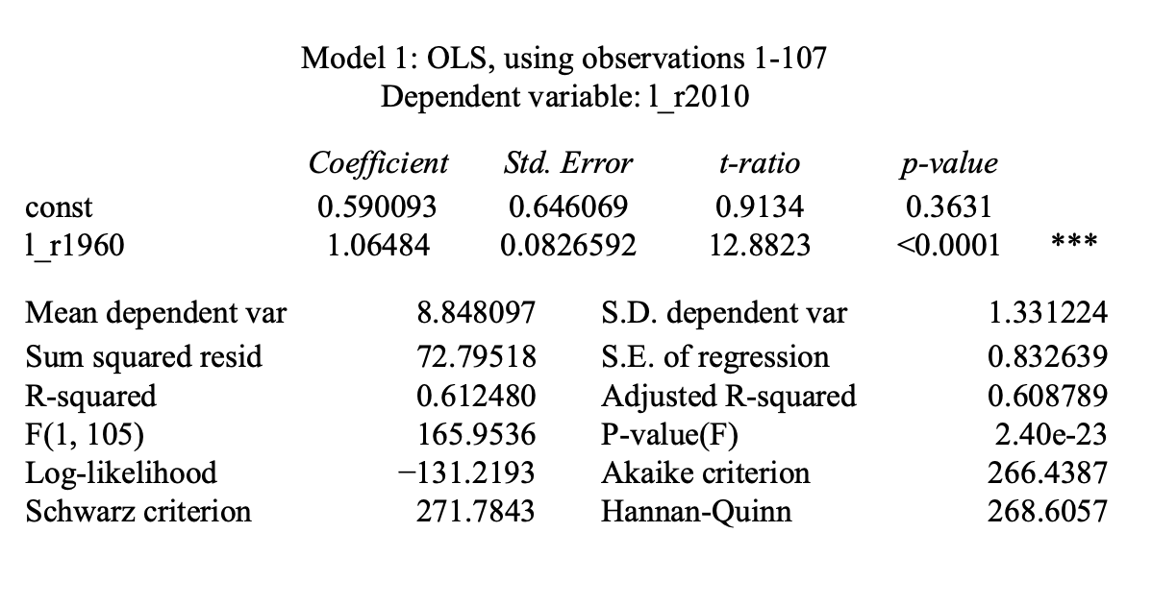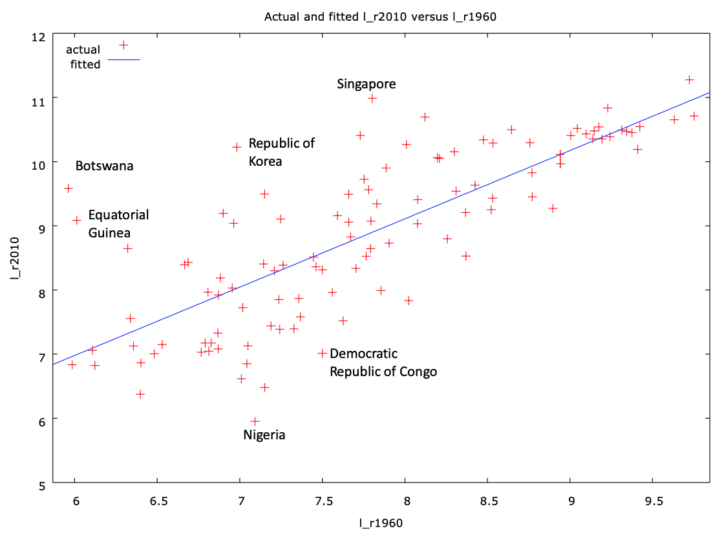

* Residuals show ‘winners and losers’
* E.g. “Singapore did better than regression expected”, “Nigeria did worse”

***3.1: Interpretation of Regression***

* Good results: due to (+) capital, (+) physical capital, (+) human capital and technology
* Bad results: not enough to use the same three ideas as above

***3.2: Fundamental Causes***

* Why? …
* Nigeria fail to invest more capital…
* Education low…
* Human capital not utilised well…
* *War, corruption, environmental problems etc.*

**4: Convergence Hypothesis**

* Growth rates of GDP/Capita **(-) corr.** to initial GDP/Capita
  + Lower Y/Capita countries 🡪 higher growth rate
  + Poorer countries eventually catch up w/ GDP/Capita
  + Catch up can give rise to Convergence

**5: Beta Convergence**

* When cross-section regression of (1) (time-averaged) growth rates on initial log GDP/Capita, (2) coefficient on initial levels is (-), (3) implying poorer countries grow faster
* Cross-sectional regression:
 $g_{i}=α+β\log{rGDPc_{i}+u_{i}}$

 + Where:
 $g_{i}=Avg. Annual Growth in rGDPc in Country i between t \& t+1$

 $rGDPc_{i}=GDP per Capita in PPP 2005 US\$ in t$

+ Test:
$β<0$

$If p-value<0.01: Evidence of Convergence$

* Convergence where:
* Similar tech, human capital endowments etc.
* “Convergence Clubs”
* “Conditional Convergence”

**Lecture 4: Univariate Unit Root Tests (Econometrics)**

* Time Series Issues:

1. Time lag
2. Spurious regression problem: if variable non-stationary

* Use logarithmic values of variables to clean up – reduce skewing
* General Rule
* Non-stationery t.s. variables should not be included in regression
* Convert to stationary before hand
* Exception to rule: variables cointegrated

**1: Time-Lag**

* Time-‘til-impact of explanatory variable
* Time-Series notation: $t=1,2,…,T$
* Lagged Time-Series Notation: $Y_{t-1},Y_{t-2},…,Y_{t-T}$
* **Time Series Plots**:
  + ${∆Y}_{t}=Y_{t}-Y_{t-1}$: measures change in variable
  + $100\left({∆Y}_{t}\right)$: % Change
* Yield of 10yr Gilts & 3month T-Bills are good (in-slide) examples
* **Time Series Results Properties**:
  + Not present in cross-section: corr. across observations
  + Autocorrelations: corr. of variable and its lag (${Y_{t} \& Y}_{t-p}$)
* Autocorrelations:
 $r_{p}=corr(Y_{t},Y_{t-p})$

 + Calculates series of autocorrelations for
 $p=1,…,P \{maxp=P\}$

   - E.g. $P=12$ for monthly data

**2: Autoregressive Model**

* All previous regression components hold
* Introduces: stationarity, non-stationarity, uni-root
* Models:
  + AR(1): $Y_{t}=α+{ρY}_{t-1}+u_{t}$
  + AR(2): $Y_{t}=α+{ρ_{1}Y}_{t-1}+{ρ_{2}Y}_{t-2}+u_{t}$…
  + AR(p): $Y_{t}=α+{ρ_{1}Y}_{t-1}+…+{ρ_{p}Y}_{t-p}+u_{t}$

***2.1: AR(1) Model***

$Y_{t}=α+{ρY}_{t-1}+u_{t}$

${∆Y}_{t}=α+{(ρ-1)Y}_{t-1}+u_{t}$

$ϕ=\left(ρ-1\right)$

${∆Y}_{t}=α+{ϕY}_{t-1}+u_{t}$

* For more generalised models (more lagged terms)…
* AR(1) Stationarity
  + *“The way that a set of data changes over time does not change”*
  + If $\left|ρ\right|<1$: $Y$ stationary so…
  + Constant Mean: $E\left(Y_{t}\right)=\frac{α}{1-ρ}$
  + Constant Variance: $Var\left(Y_{t}\right)=\frac{σ^{2}}{1-ρ^{2}}$**(-1 $→$ 1)**
  + Autocorrelations (dep. $ρ$& $s$): $Corr\left(Y_{t},Y_{t-s}\right)=ρ^{s}$
* AR(1) Non-Stationarity
  + If $\left|ρ\right|=1$: $Y$ non-stationary and has unit-root so…
  + Indeterminate mean and var.: $Var\left(Y_{t}\right)→∞$**(-1 or 1)**
  + Autocorrelations: $Corr\left(Y_{t},Y_{t-s}\right)=1$
  + *“Here, $Y$ does not satisfy classic assumptions e.g. key variances in confidence intervals and hypothesis tests will tend towards infinity”*
  + Hence, do **not** include unit-root variables in regression models
    - Unit-Root test: H0 = *data has unit root (ADF test in Gretl)*
    - Hence, if p < 0.05: reject; p > 0.05: fail to reject
    - tau-stat: < 0.35: insignificant; fail to reject

***2.2: AR(p) Model***

$Y_{t}=α+{ρ_{1}Y}_{t-1}+…+{ρ_{p}Y}_{t-p}+u_{t}$

* Meaning: ${∆Y}_{t}=α+{ϕY}_{t-1}+{γ_{1}∆Y}_{t-1}+…+{γ_{p-1}∆Y}_{t-p+1}+u_{t}$
* Slope coef.’s in transformed regression are functions of those in first regression
  + E.g. $ϕ=ρ_{1}+ρ_{2}+…+ρ_{p}$

**Lecture 5: Technological Progress & Growth**

* **Unsustainable** growth: Capital Accumulation (diminishing returns)
* **Sustainable** growth: Technological Progress
  + *“Capital/Worker increases due to state of technology”*

**1: Progress Overview**

* Automation etc.
  + Larger quantities of output
  + Better quality products
  + New product development
  + Time-to-development increase
  + Larger variety of products
  + Less staff required

**2: Expanding the Production Function**

* + *AN:* refers to more efficient workers with **state of technology** *A*
  + *AN* = Efficiency Units(reduces amount of workers (*N*) required)
  + *N* = Worker; *AN* = Effective Worker
* 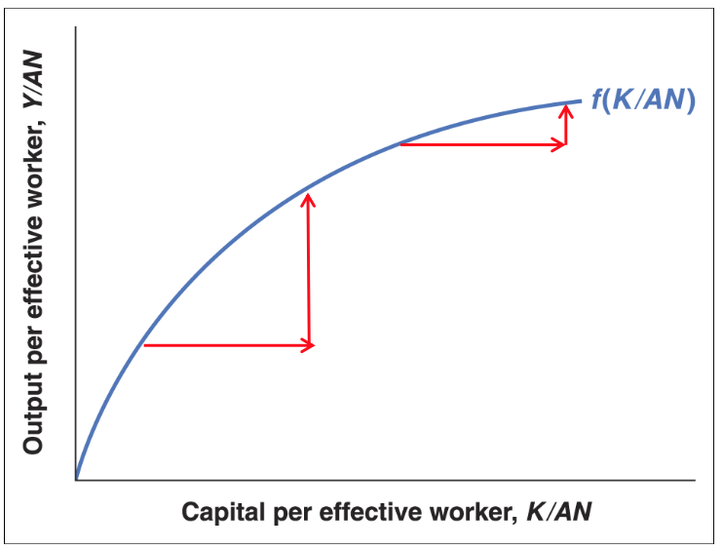**Returns to Scale**:
 $λY=Y\left(λK,λAN\right)$

 + Decreasing returns to capital still mean   
    diminishing increases per **effective   
    worker**

**3: Expanding the Solow Model**

* Relax these assumptions:
  + *gA*: Growth of **Technology** (Exogenous)
  + *gN*: Growth of **Number of Workers** (Exogenous)
  + *Exogenous: a given – not determined inside model*
* Investment:
  + Recall: $I=S=sY$; $S=Saving;s=Saving Rate$
  + Now: $\frac{I}{AN}=s\frac{Y}{AN}=sf\left(\frac{K}{AN}\right)$
  + *“Investment req. for capital to improve an effective worker”*
  + **Steady-state** of capital holds for effective workers

***3.1: Optimal Investment for Constant Capital/Effective Worker***

* Before: *I* equal to $δ$ to keep *K* constant – *K* must rise in proportion to *AN*
* Effective worker *g*: technology *g* + population *g*

$g_{AN}=(g_{A}+g_{N})$

$∴\frac{I}{AN}=(δ+g_{A}+g_{N})\frac{K}{AN}$

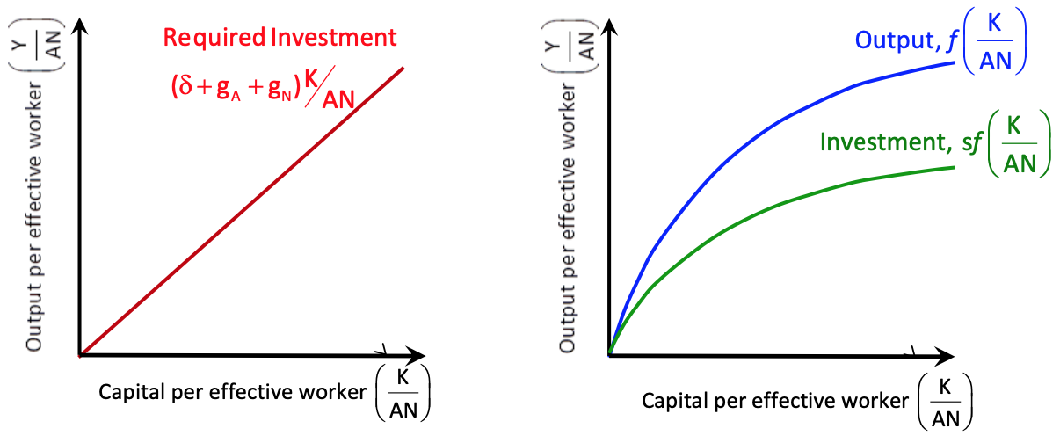

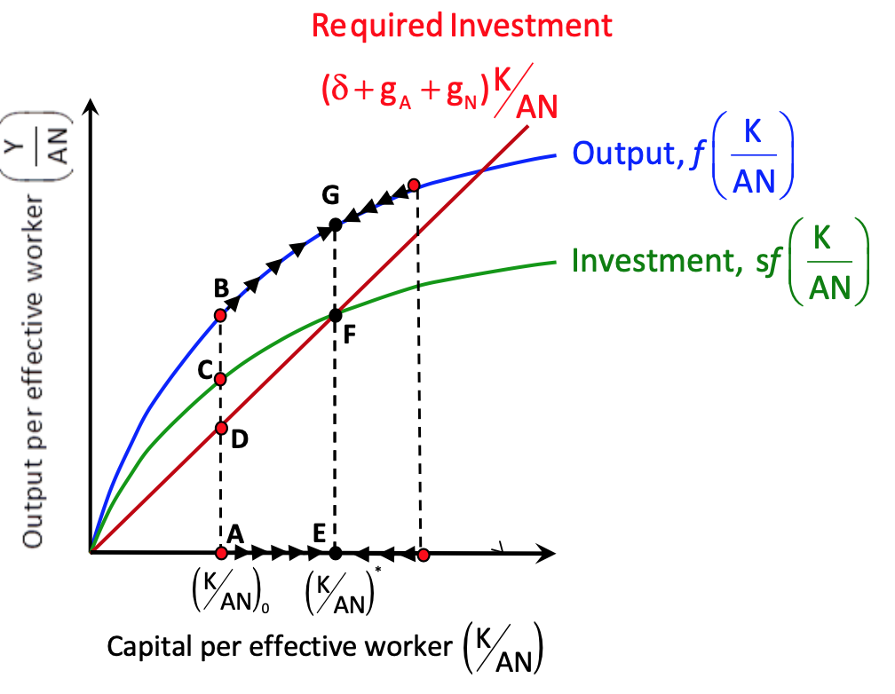**4: Steady-State – Balanced Growth**

* **A**: actual *I* > req. *I* so $\frac{K}{AN}$ rise
* **E**: optimal
* *Constant $\frac{K}{AN}$* and constant $\frac{Y}{AN}$
* *Therefore, as Technology grows at gA,  
   Workers also grows at gA*

***4.1: Rates of Growth***

* $\frac{K}{AN}$: 0
* $\frac{Y}{AN}$: 0
* $\frac{K}{N}$: *gA*
* : *gA*
* : *gN*
* : *gA* + *gN*
* : *gA* + *gN*

**5: Saving Rate Rise**

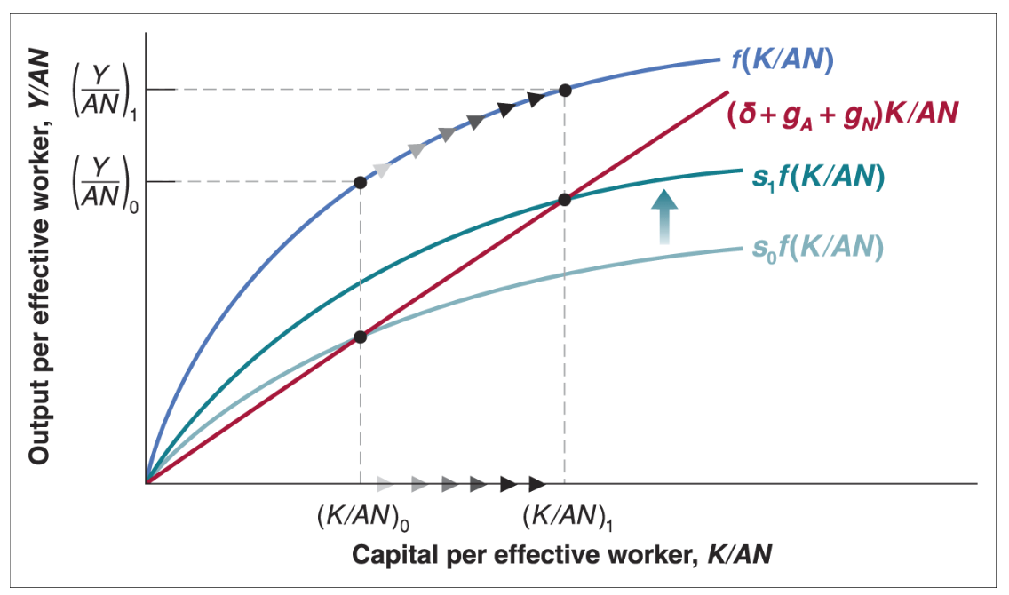

* 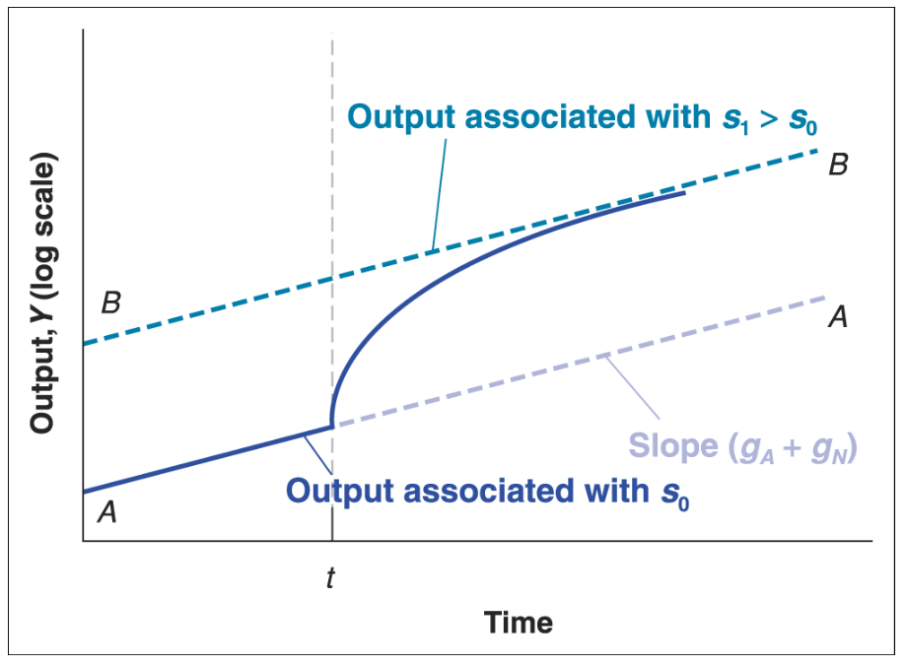Raises everything   
  until new **steady-rate**
* Higher *g* until new  
  **steady-rate**

**6: Limitations of Solow**

* Shows **sustained growth** arises from Technology but doesn’t explain it
* Therefore, Technology still determined **Exogenously** (outside the model)
* Must consider what determines Technology

**7: Determinants of Technological Progress**

* *Result of firms’* ***Research & Development***
* Spending on R&D depend on:
  1. **Fertility/Credibility** of ideas/breakthroughs stemming from research
  2. **Appropriability** of results – extent to which firms will benefit

***7.1: Fertility/Credibility***

* **Basic research** (general principals) interaction w/ **applied research** (application)
* **The country**’s skill differs on basic and applied research
* **Time** it takes for discoveries to be realised

***7.2: Excludability***

* *Degree of excluding other firms from using your development*
* No patent: **low excludability**; Patent: **excludability**
* Non-excludability may discourage *I*
* Trade-off: too much/too little protection

***7.3: Governments Encourage R&D***

* Gov. spending on R&D
* Tax incentives for R&D
* Patents
* University funds for research

***7.4: Countries’ Choices***

* Less Technologically advanced: poorer patents – usually **users** over **producers**
* Here, productivity increases likely reflect **adaptation** over **innovation**

***7.5: Management Practices***

* Good management encourages Technological progress
* Blooms India Experiment: **Controlled** and **Treated** groups show this – **Casual**
  + Quality, production methods, inventory manage, order fulfilment
  + Treated: Productivity increased by 10%
  + Treated: Defects reduced by 60%
  + Treated: Profitability increased by $200m
  + Control Group: less than 1% productivity increase

**8: Facts of Growth – Fast Technology Progress**

* Fast growth **convergence** from two sources:
  + Higher rate of Technology progress *gA* (*gY = gA + gN*)
  + Adjustment of $\frac{K}{AN}$ raises $→$ (*gY = gA + gN*)

***8.1: Solow Residual***

* *‘Rate of Growth of Total Factor Productivity’*
* How much of a given increase in *Y* is attributed to *K* or *N*
$g_{A}=g_{Y}-({αg}_{N}+(1-α)g_{K})$

* Poorer countries are poorer because of less $\frac{K}{AN}$
  + *K* is accumulated faster than other countries’ however – fast temporary *g*
  + Technological levels **converge** and so too does $\frac{Y}{N}$

**9: Institutions & Growth**

* *Resources may be used* ***more****/****less*** *efficiently*
* **Institutions**: describes set of **rules, organisations, social structures, customs** which influence behaviours of individuals/firms through *I, K, A,* organisation of *Y*
* **Inefficiency**: crime, corruption, lawlessness
* *“Can poorer institutions explain why some poor countries aren’t catching up?”*

***9.1: Institutions & Growth***

* Property rights protect property from expropriation by gov. and firms
* Required to enhance incentives to undertake *I*
* **Law & Order – Judicial System**: must enforce this idea
* **Corruption-Free Governments**: promote competition, enforce contracts
* *Crime and corruption are deterrents to I*
* **Good Government Policies**: organise and finance
  + Education
  + Health-care
  + Transport
  + Comms
* **Bad Government Policies**: detrimental for growth
  + Regulation making it hard to set up firms
  + High taxes on *Y* from *K* deter *I*
  + Dictators and corruption leads to bribes, fees, fear, deter *I*
* *“Pressure from well-functioning K markets help financial capital flow to best I projects”*

**Lecture 6: Financial Markets & Expectations**

* **Expectations** influence future income, future profits, future interest rates etc.
* Previously (EC216): Money & 1-Year Bonds. Now:
  + Short-Term Bonds
  + Long-Term Bonds
  + Stocks
* Asset Prices:
  + **Current** & **Expected** activity
  + Impact economy through **consumption** and **wealth** relationships

**1: Recalling Old Rules & Formulae**

* Compound Interest:
  + Standard: ${CF}_{t}=CF{\left(1+i\right)}^{t}$
  + Uncertain Future *i*’s: ${CF}_{t}=CF\left({1+i}_{t}^{e}\right)\left({1+i}_{t+1}^{e}\right)…({1+i}_{n}^{e})$
* Expected Present Discounted Value:
  + Standard: ${CF}_{0}=\frac{{CF}_{t}}{{\left(1+i\right)}^{t}}$
  + Uncertain Future *i*’s: ${CF}_{0}=\frac{{CF}_{t}}{\left(1+i_{t}^{e}\right)\left(1+i_{t+1}^{e}\right)…\left(1+i_{n}^{e}\right)}$

***1.1: Nominal vs. Real Interest***

* Want **real** value of goods rather than value in **currency**:

$V_{0}=\frac{{CF}_{0}}{P_{t}}$

**2: Bond Markets**

* Inferring Bond Yield: $i_{t}=\frac{{V-P}_{t}}{P_{t}}$
* Yield to Maturity: Constant *i* which makes PV equal to P today

***2.1: Comparing Different Maturities***

* **Example**: Roll-over 1-year bond vs 2-year bond:
  + $100{\left(1+i_{2}\right)}^{2}=100\left(1+i_{1}\right)\left(1+i_{2}^{e}\right)$//Equilibrium//
  + //Divide Both Sides By £1// //Multiply Brackets//

$i_{2}≈\frac{1}{2}\left(i_{t}+i_{2}^{e}\right)$

***2.2: Yield Curves***

* **Upward** **Sloping**: long-term *i* > short-term *i*
* **Downward Sloping**: long-term *i* < short-term *i*
* *Markets expect short-term rates to be higher in the future*

***2.3: Terms***

* **Gov. Bonds**: Issued by government agencies
* **Corporate Bonds**: Issued by firms
* **Bond Rating**: Issued to rank and price bonds
* **Risk Premium**: Difference between *i* paid on given and *i* paid on highest rated
* **High Default-Risk**: Junk bonds
* **Discount** **Bonds**: Single maturity payments (face value)
* **Coupon Bonds**: Pay periodic coupons
* **Coupon Rate**: Ratio of coupon payments to face value
* **Current Yield**: Ratio of coupon payment to price of bond
* **Life of Bond**: Time until maturity form any given *t*
* **Index-Linked Bonds**: Promises to pay adjusted for inflation (UK Index-Linked Gilts)
* **Inflation Compensation/Breakeven Inflation Rate**: the inflation rate which leaves risk-neutral investor indifferent between normal or index-linked bonds

**3: Stock Market**

* Firms raise funds:
  + Issuing corporate bonds (debt)
  + Taking bank loans (debt)
  + Selling ownership – **stocks** (equity)
* Asset value = price (PV of future CFs)
* Investors want to hold assets w/ highest E(R)

***3.1: Value of Stock***

$P_{0}=\frac{{div}_{t+1}^{e}}{(1+i_{t})}+\frac{{div}_{t+2}^{e}}{(1+i_{t})(1+i_{t+1}^{e})}+…+\frac{{div}_{n}^{e}}{\left(1+i_{t}\right)…\left(1+i_{n-1}\right)}$

***3.2: Comparing One-Year Bond to One-Year Stock Investment***

* (1) Buy 1-year bond, (2) hold 1-year of stock
* Every £1 buys you: $\frac{£1}{P_{0}}$
* Each yr. you want: $P_{t+1}^{e}+{div}_{t+1}^{e}$
* Hence, Expected Return on **stock**:
$E\left(R\right)=P_{t+1}^{e}+{div}_{t+1}^{e}\left(\frac{£1}{P_{0}}\right)→\frac{P_{t+1}^{e}+{div}_{t+1}^{e}1}{P_{0}}$

* Compared to bond:

$£1\left(1+i_{t}\right)=\frac{P_{t+1}^{e}+{div}_{t+1}^{e}}{P_{0}}$

${∴P}_{0}=\frac{P_{t+1}^{e}+{div}_{t+1}^{e}}{\left(1+i_{t}\right)}$

$∴P_{t+1}^{e}=\frac{{div}_{t+2}^{e}}{(1+i_{t+1})}+\frac{{div}_{t+3}^{e}}{(1+i_{t+1})(1+i_{t+2}^{e})}+…+\frac{{div}_{n+1}^{e}}{\left(1+i_{t+1}\right)…\left(1+i_{n}\right)}$

**Lecture 7: Consumption & Expectations**

* Recall:
$Y=C+I+G+\left(X-IM\right)$

$C=C\left(Y_{D(+)}\right); Y_{D}=(Y-T)$

* However, people are willing to **borrow** when *YD* is low
* 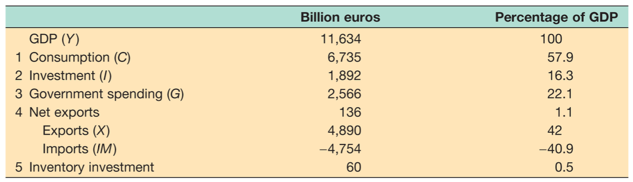As an economy:
* *C* and *Real GDP* move together but *C* is less volatile/‘smoother’

**1: Consumption Expectations**

* *C* decisions depend not only on personal ***Y*** but also {***E(Yt)*** and ***YHousehold***}
* The idea of *C* only depending on *YD* is disproven by **fear of depression** i.e. in the Lehman Brothers’ collapse – shifts the consumption function
  + I.e. News of depression $→$ fear of unemployment $→$*C* decreases
  + I.e. w/o *YD* decrease – worry about the future:
  + 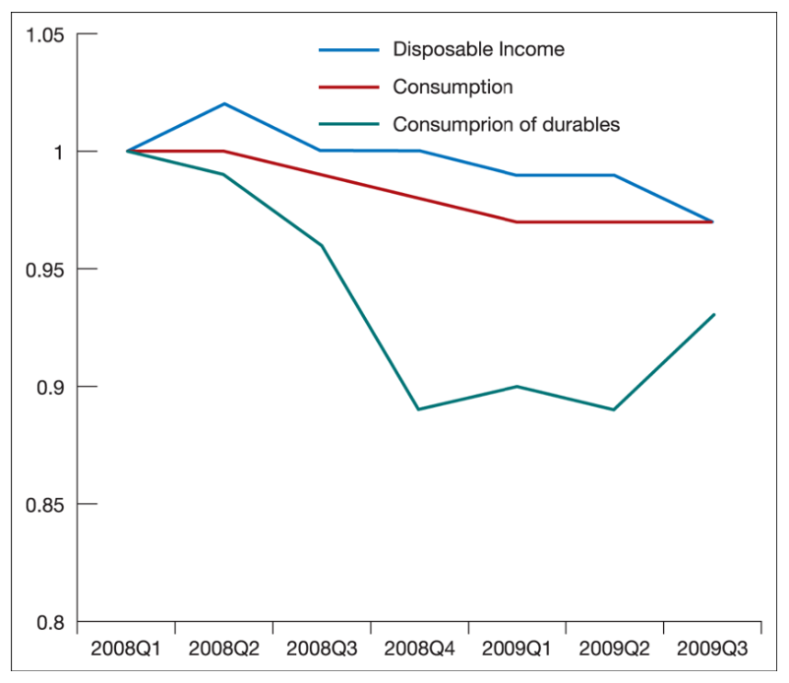

**2: Consumption Theory**

* *Friedman & Modigliani*

1. Total wealth and its components
2. Decision making as a ‘foresighted’ consumer
3. Two-period *C* model

* Consumers look beyond current income
* Consumers have a planning horizon of **life**
* Forward-looking: resources can be transferred across time (**borrowing/lending**)
* *C* depends on **total** **wealth** rather than just *YD*
* Although future personal *Y* fluctuates, people maintain reasonably consistent *Y:*
  + **Borrow** when *Y* is low
  + **Saving** (lending) when *Y* is high

**3: Total Wealth & Components (1)**

* **Total Wealth** = {*WHuman* + *WFinancial* + *WHousing*}
  + **Human Wealth** = *PV(E(Labour Y))*
  + **Financial Wealth** = *Contents of Bank Account*, *Savings, Bonds/Stock*
  + **Housing Wealth** = *Value of House – Value of Mortgage Debt*

**4: Decision Making As ‘Foresighted’ Consumer (2)**

* How would they make *C* decisions?

1. Calculate Total Wealth
2. Decide how to spend proportion each year
   * **Borrowing** if: *Ct > Yt*
   * **Saving** if: *Ct < Yt*

* Are you foresighted?
  + Are you in debt today?
  + What assets do you own?
  + Work out *E(YD, Lifetime)*
* Work out *E(YD, Lifetime)*:
  + Expected starting salary €40,000
  + Expected proportion of this to pay in tax 25%
  + Expected annual salary increase 3% avg.
  + Expected work lifetime before retirement 22 $→$ 60 (38yrs.)
  + Expected retirement lifetime 18yrs.
 ${E(Y}_{t+1}^{e}-T_{t}^{e})=Y_{Initial}*r_{Y, Retained}*(1+{(1+r_{Y, Increase})}^{t})$

 $=40000*0.75*\left(1+1.03+{1.03}^{2}+…+{1.03}^{38}\right)$

$=$ + £2166000
* How much should they consume?
  + Age = 19; Exp. Live = 78; Remaining Life = 58
  + Spend/Year = $\frac{2166000}{58}$ = £37344
  + Implies: **borrow $37344$**  until age of 22 (work start)
* Is this plausible?
  + May not intend to maintain constant *C* over lifetime (e.g. leisure, family)
  + Human Wealth based on future earnings which may end up being a lot less
    - Consumers may wish to borrow smaller to protect themselves
  + Banks may be unwilling to extend such credit to younger people
* More realistic – *C* depends on two factors:
  + **Wealth**: consumers are forward looking, to some degree
  + **Current *YD***: consumers unwilling/able to implement consistent *C* plan
* Liquidity constraints: consumers may not get credit – sensitivity of *C* to current *Y*

**5: Two-Period Consumption Model (3)**

* Shaded area represents affordable combinations
* Note that *PV(C)* & *PV(Y)* are equal
$C_{1}+\frac{1}{(1+r)}C_{2}=Y_{1}+\frac{1}{(1+r)}Y_{2}^{e}$

* Slope of the Consumption Indifference Curves is **MRS** of money in ea. period
  + Gives optimal *C*
* Shows **compounded interest** (*C2*)vs. **borrowing to spend now** (*C1*)

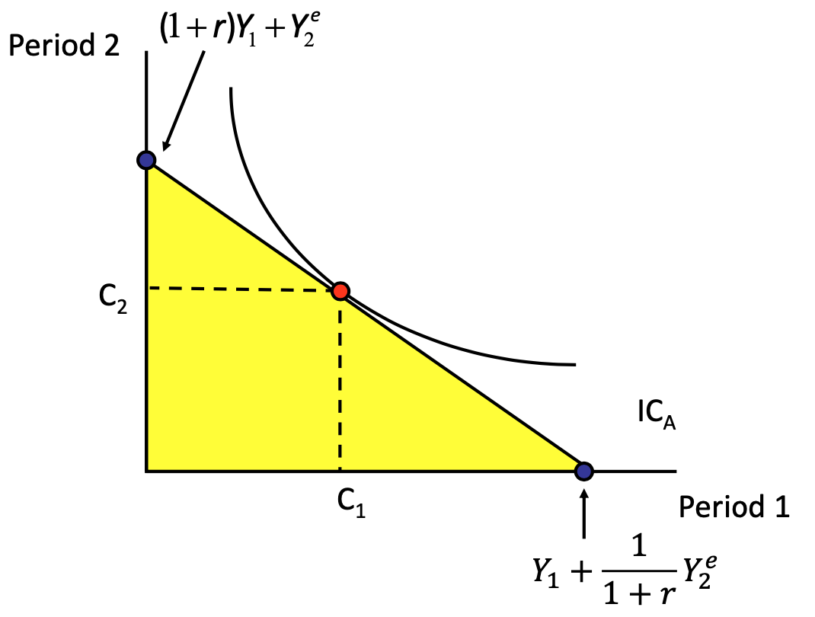

* Optimal *C* affected by how PV lifetime income is distributed over P1&2

***5.1: Period 1 Saver Behaviour***

* Expects lower income in Period 2
* Saves Period 1 income
* Leads to more equal consumption over the periods

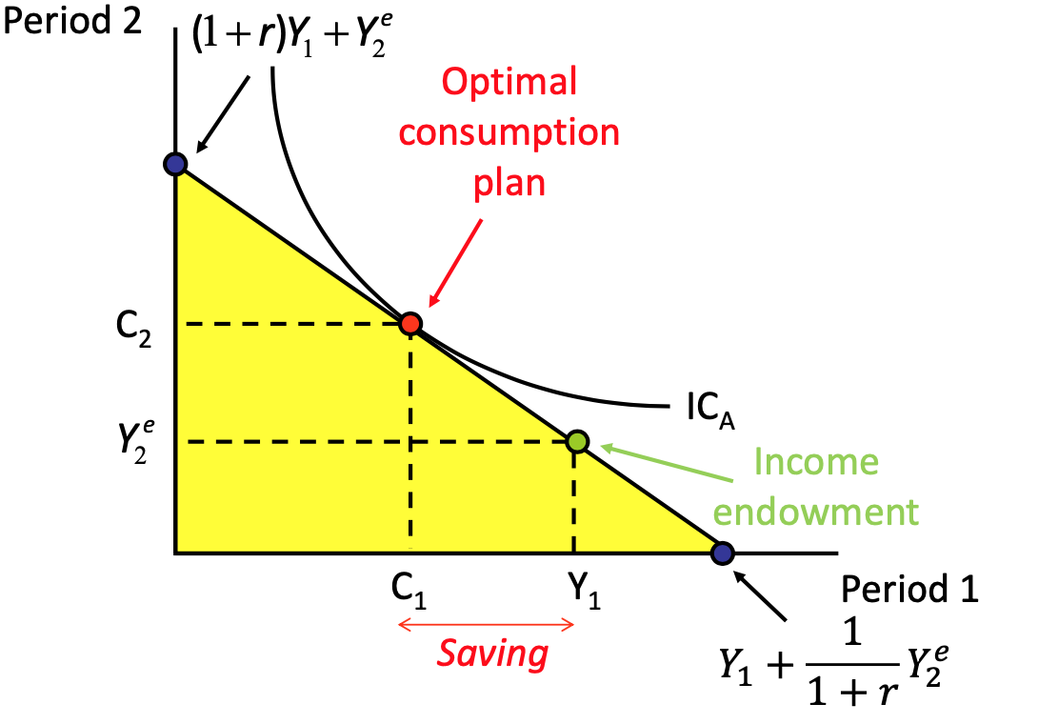

***5.2: Period 1 Borrower***

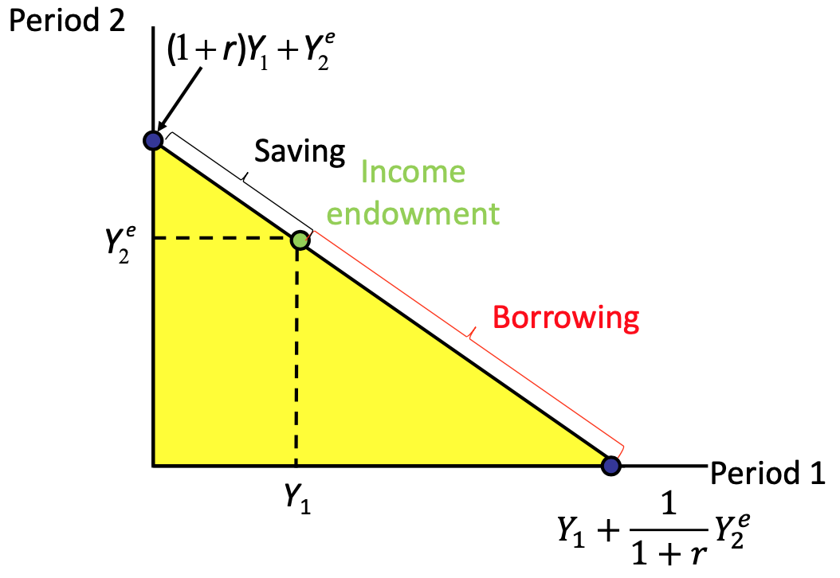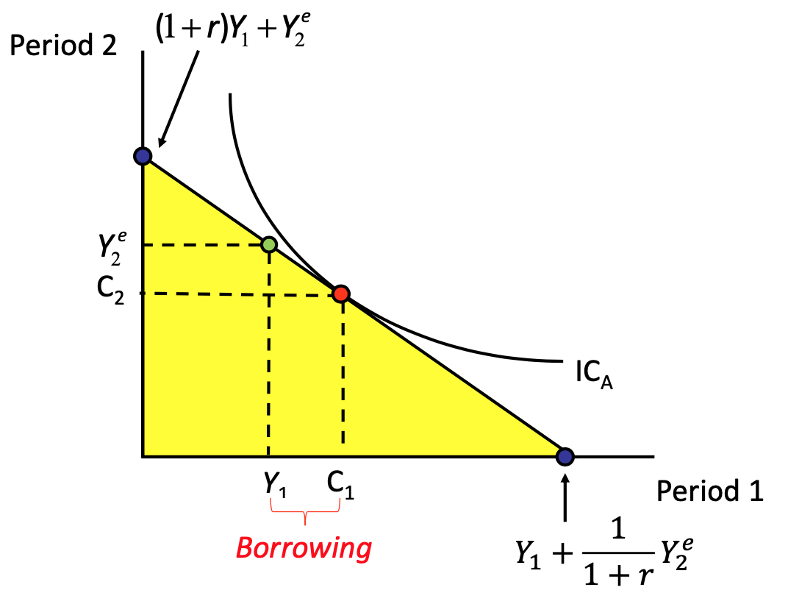

🡪

***5.3: Impact of Rise in Y1***

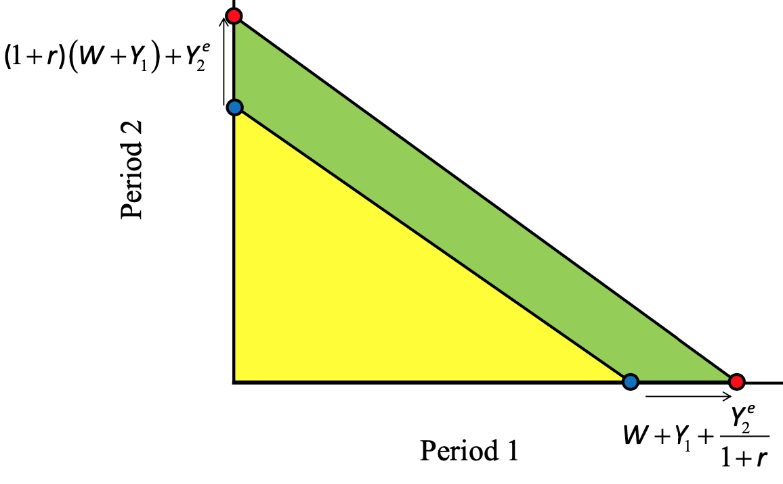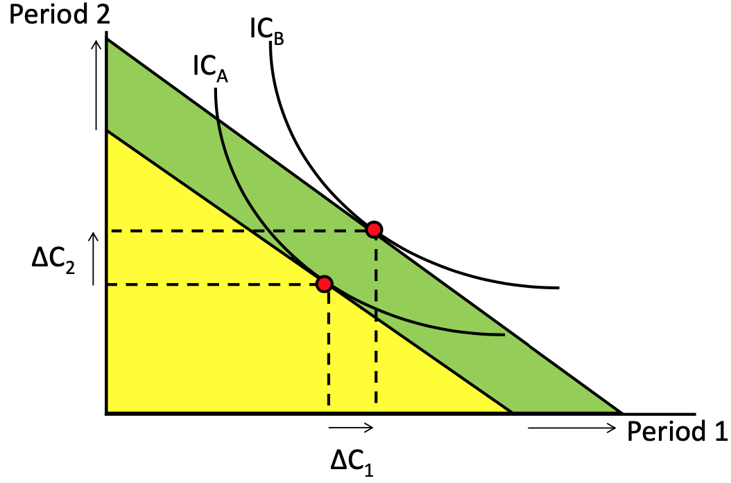

🡪

***5.4: Impact of Rise in r***

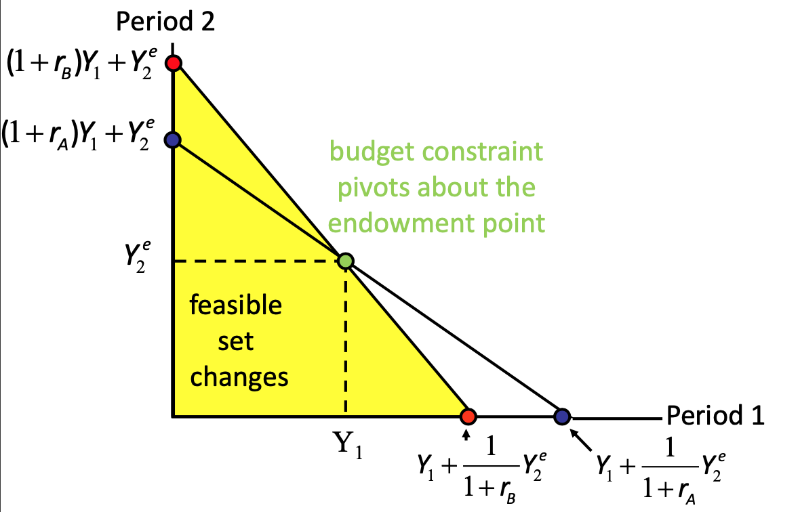

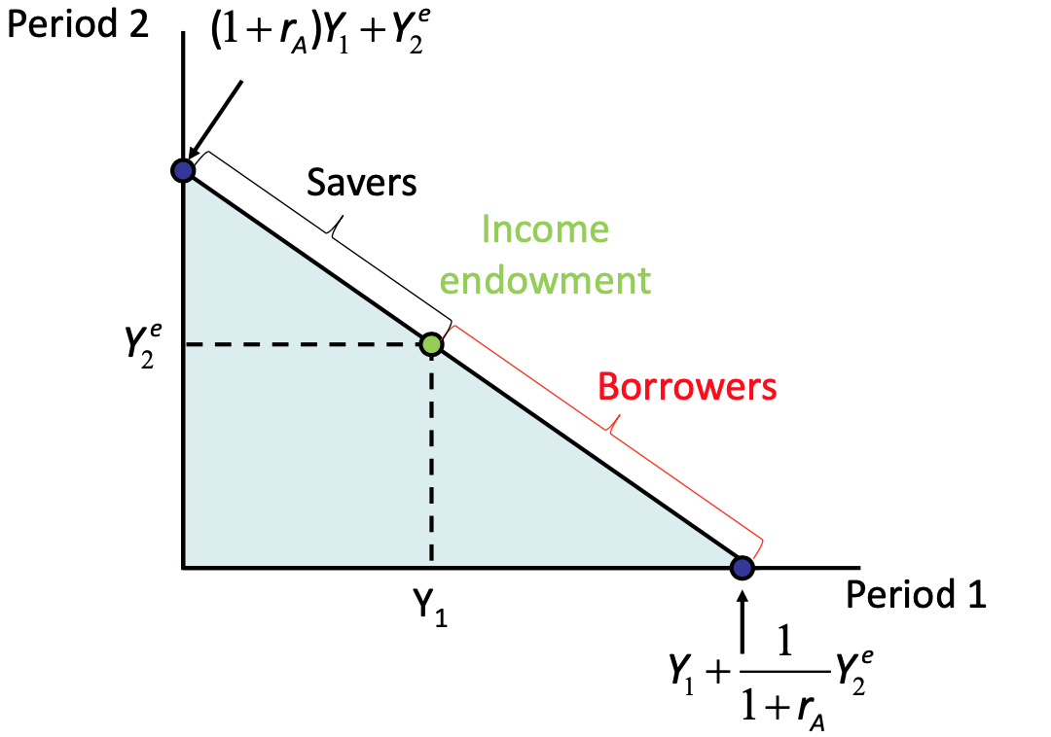

**🡪**

1. Substitution Effect:
   * Every £1 spent in P1 means (1+*r*)£ less available in P2
   * As *r* rises, a £1 of *C1* is proportionately bigger loss of *C2*
   * Result: sub away from 1 to 2
2. Income Effect:
   * Savers: as *r* rises, get higher interest payments – spend more of *C2*
     + Consumption Smoothing – more *C1* **&** *C2*
   * Borrowers: must pay more interest on borrowing – spend less *C1*

***5.5: Liquidity Constraints***

* Assumed consumer easily obtain credit – **not true**
  + The rich have easy access, the poor may have low credit scores and are likely to consume out-with income (i.e. overdraft and loans)

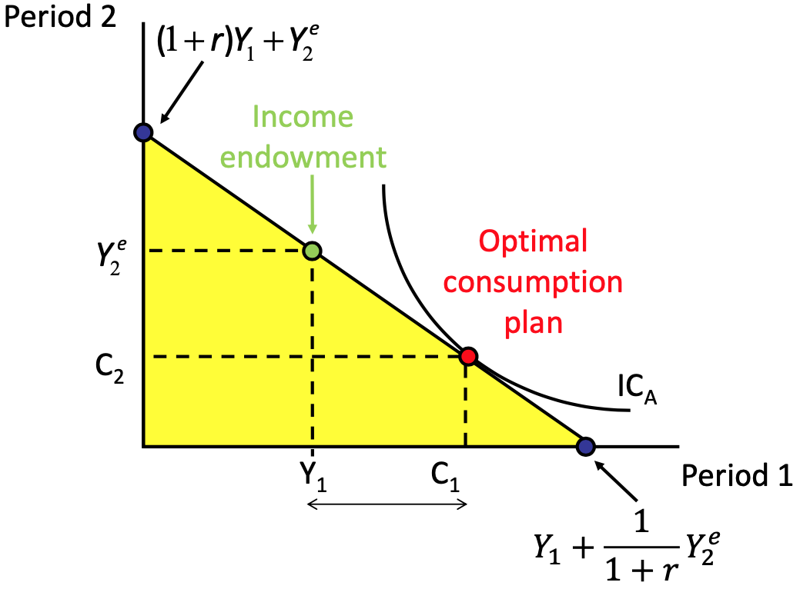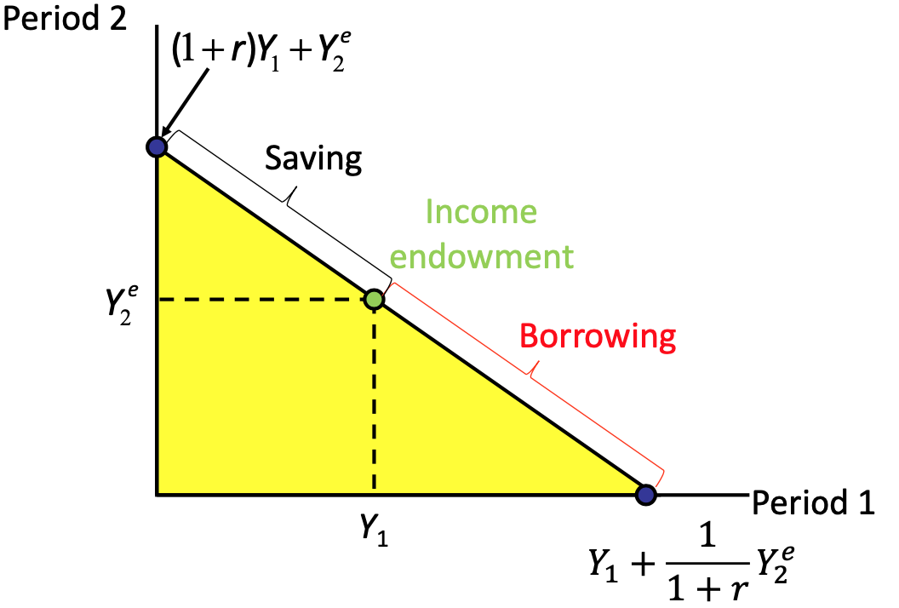

* 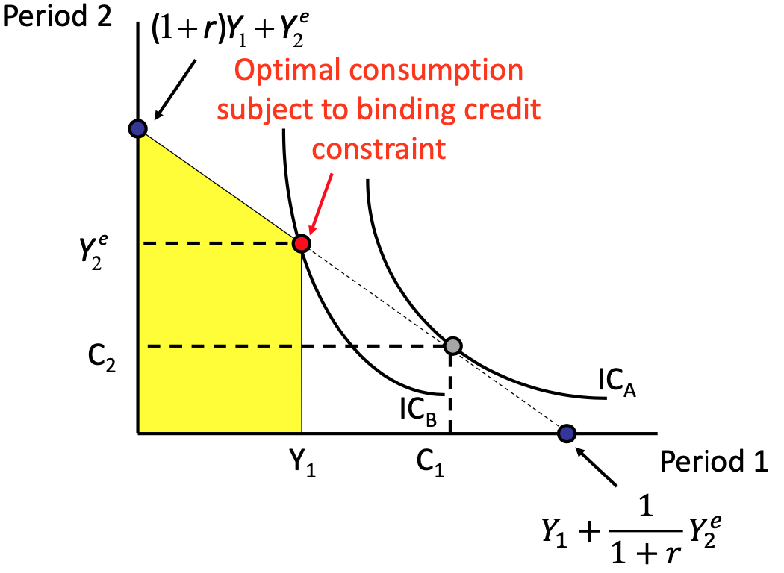Recall:

🡪

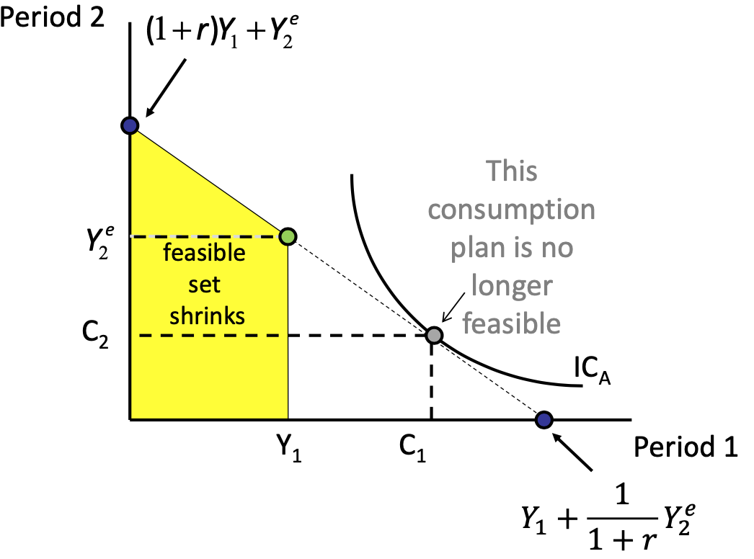

🡪

***5.6: Transitionary Income Change***

* Fall in *Y1* but reversed in P2 such that PV lifetime *Y* unaffected
* Ea. period of *C* is **unaffected** provided all consumers who want to consume > *Y1* at P1 have credit access – **smooth path of consumption**
* But, some face **binding credit constraints** in P1 so limits *Y1* & *Y2*
* **No liquidity constraint**: change *C* in line with E(after-tax labour *Y*)
* **Liquidity** **constraint**: only consume out of *YD*

**6: Conclusions**

* **Direct** **Expectation** **Impact**: human wealth i.e. future labour *Y*, real *i* and tax
* **Indirect** **Expectation** **Impact**: non-human wealth i.e. bonds, housing = financial markets
* Response of *C* to *Y* change depends on perception of **permanent** or **transitionary**
* *C* likely to respond less than 1-for-1 to current *Y* fluctuations
* *C* may move even if current *Y* doesn’t – pessimism/optimism about future tax etc.

**Lecture 8: Investment & Expectations**

* PV of E(future profits)
* Influences of current and E(profit)
* Investment
* Comparing volatility of *C* and *I*
* **Gross Capital Formation**: producers’ outlays on additions to capital assets of economy (plus net changes in inventories)
* **Additions to Capital Assets**: new buildings, vehicles, aircraft, machinery, infrastructure etc.
* **Demand** side: *I* is volatile, link to financial markets thus, *i* and monetary policy
* **Supply** side: L-R growth related to size of capital stock
* Contributions to UK growth:

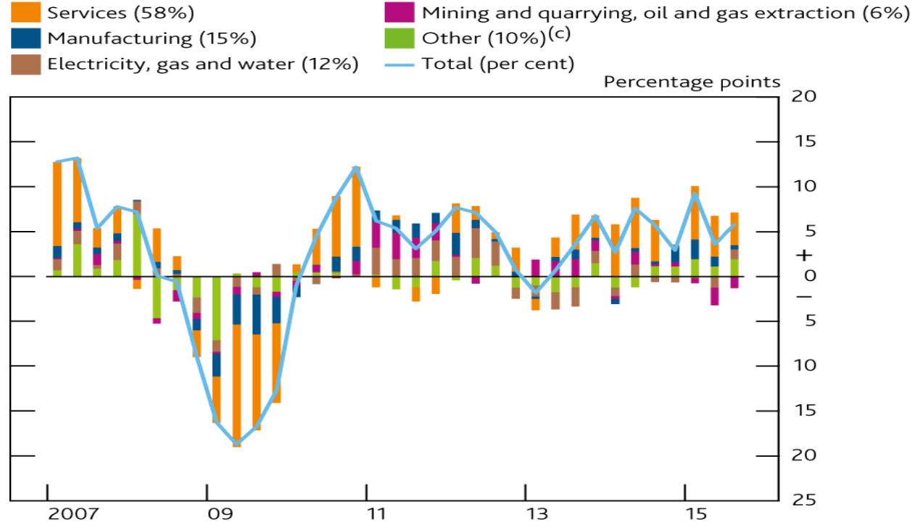

**1: Business Investment Recap**

* Depending on *Y* and *i*
$I=I(Y_{(+)}{,i}_{(-)})$

* **Example** (sales rise):
  + Increased sales $→$ buy new machines $→$ increase production $→$ increased investment $→$ increased sales
  + If **borrowing**: higher *i*, less attractive
    - At some level will achieve additional profits needs w/ new machines through
    - In other cases, profit will not cover *i* payment
  + If **equity-funded**: holds, but for different reason
    - Higher *i* would encourage firms to lend money to receive *i* rather than spending it

**2: Expectations & Investment**

* Now add E(Future)
  + Must consider (1) **PV(New Investment)** income vs. (2) **Cost**
  + Wear/tear also must be included – (3) **Depreciation**

**3: Notation**

* + Buildings: 2-4% p.a.
  + Machinery: 4-15% p.a.
* So Far:

$I_{t}=I\left({V{(π}_{t}^{e})}_{\left(+\right)}\right)$

**4: Current Profit & E(Profit)**

* Driving *I*: $V{(π}_{t}^{e})$ (Future Profit discounted), rather than **CFs** (Current Profit)
* But, still remain with current profit influence (Oil **Example** – Slide 25)
* So Far:

$I_{t}=I\left({V{(π}_{t}^{e})}_{\left(+\right)}, π_{t\left(+\right)}\right)$

***4.1: Borrowing Impact***

* If Current Profit low:
  + May be reluctant to borrow in anticipation of failure
  + Potential lenders may not be convinced in project integrity
* *“High Current Profit eliminates borrowing needs”*

**5: Sources of Finance for Investment**

* Investment as a function:
  + - Level of sales (Income)
    - Existing Capital

**6: Investment & The Stock Market**

* Firm’s Financial Value: stock market value + outstanding bonds
  + Measures value investors place on capital which is already in place
* *Should invest when financial value of capital exceeds cost of additional unit:*
  + - : Buy more capital
    - $q<1$: Don’t buy more capital, wears out
  + Therefore: (+) relationship between *I* and $q$
* **Example** (pessimism about Future Profitability):
  + Stock prices fall;
  + $q$ falls;
  + $I$ falls;
  + Negative demand shock
* Extended to Consumption:
  + Reduce household wealth;
  + Shift consumption function **down**;
  + Negative demand shock

**7: Volatility of Investment & Consumption**

* Similarities in Consumption and Investment behaviour:
  + Consumers (*C*): Whether *Y* change is **transitory** or **permanent**
  + Firms (*I*): Whether current sales change *Y* is **transitory** or **permanent**
* Differences in Consumption and Investment behaviour:
  + When consumers see *Y* increase, they respond w/ almost equal *C* increase
  + When firms see *Y* increase (believed to be permanent), PV(*Ye*) increases, therefore *I* increases
* **Conclusions**:
  + *C* and *I* usually move together (+);
  + *I* far more volatile than *C*;
  + *I* much smaller than *C*, so changes in *I* get smaller from yr. to yr. following *C* changes

**EC316 Test Notes**

